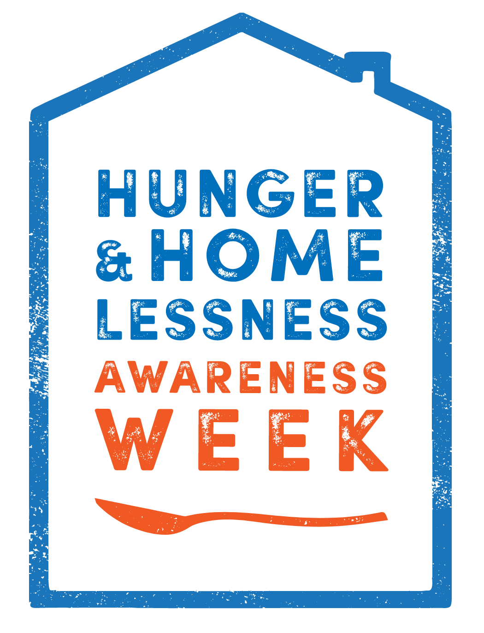

MONTH
November

Join the Fight Against Hunger this November!
Hunger and Homelessness Awareness Month
@ House on the Hill

Dropoff items at School Lobby
during regular hours.

Drop Off Deadline is Thursday November 20.

Food Items: (Stick to the List)
18 oz. Jars of Peanut Butter or Jelly - 5pts
Boxes of Hamburger Helper or Mac and Cheese - 3pts
Ramen Noodles Packets - 3pts
10 oz. Cans or Pouches Chicken or Tuna - 10pts
15oz. Cans of Green Beans, Corn, or Fruit - 3pts

Hunger and Homelessness Awareness Month
Visit www.houseonthehillbg.com for more information.
The Drive benefits low-income families and individuals in need.

Community-Wide
Food Drive

