Finance committee meeting | Location: | ZOOM CALL
Finance committee meeting | Date: | 9/2/25
Finance committee meeting | Time: | 4:00 PM
Finance committee meeting | Facilitator: | LINDSEY MCCARTY

Attendees:
Lindsey McCarty, Joel Hawkins, and John Kleis.
- Discussed current financial status and brainstormed solution to present to board.
- Current status will be presented in board meeting September 8th by providing Profit and Loss statement and YTD financial statement. Currently based on data board was made aware of in August, there are only enough funds to pay for September’s operations. Which means that in October we would have to cease operations without action items below being executed. Action items and discussion below.

- Board commitment and Board match

  - Board Commitment of $2500.00 each (donated directly from board member or raised in other ways) Starting September 8th and ends September 15, 2025. (VOTE ON)

  - Board match campaign goal ($25,000.00 board goal/$25,000.00 match raised) Starting September 16th and ends September 26th. (VOTE ON)

- Discuss a spending freeze of any current non-operational expenses. (VOTE ON)

- Note to board members and for financial committee notes that Joel has donated the first $2500.00 to board campaign as well as agreed to pay his salary out of his savings for next two pay periods at least until financial issue is resolved. Then the Board will reimburse those wages.

- Discussed Line of Credit for HOTH after board commitment met
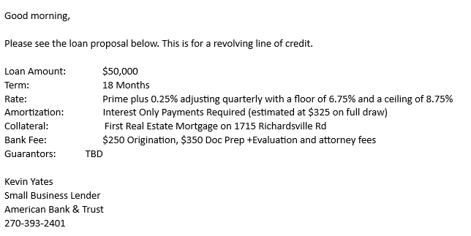

- Action Items for board meeting on September 8th:
- Vote on board commitment and match plan
- Vote on spending freeze

